**7PAM2000 Applied Data Science 1**

**Assignment 1:Visualization**

Name:Sravani Goka

Student ID:22013825

Data set: <https://github.com/Sravanigooka11/adassignment-1.git>

Table of Contents

Introduction 3

Line Plot: Average Population Growth Rate from 1961-2021 3

Bar Plot: Top ten Countries with most population growth in 2021 5

Box Plot: Population Growth Rate (2021) Region Wise 6

Conclusion 6

**Table of Figures**

Figure 1: Average Population Growth Rate from 1961-2021 3

Figure 2: Top ten Countries with most population growth in 2021 5

Figure 3: Population Growth Rate (2021) Region Wise 6

# Introduction

This report analyzes global population growth (annual) rate. The dataset examined is taken from the World Bank’s Data Repository. It contains the annual population growth rate of almost all countries of the world from the year 1961 to 2021. The data has been analyzed through python programming using pyplot library to visualize the trends in the dataset as well as to draw inferences. The major advantage of conducting this data analysis is the capacity to identify patterns and trends in population growth and demographic shifts across regions and nations. Population growth rates can affect decisions on resource distribution, healthcare, infrastructure planning, and economic development. In addition, knowing which countries and regions have high or low population growth rates can help predict future demographic transitions and identify new opportunities or risks. The visualizations provided in this analysis provide a clear and concise breakdown of population growth rates across regions and countries, making it easy to evaluate and comprehend the data.

# Line Plot: Average Population Growth Rate from 1961-2021

Line plots are commonly used to show trends over time. In this case, it shows the average population growth rate over 6 decades from 1961 to 2021, so a line plot is a good choice. By plotting the data as a line, it can be easily observed whether population growth rates are increasing or decreasing over time, and how they differ between countries.

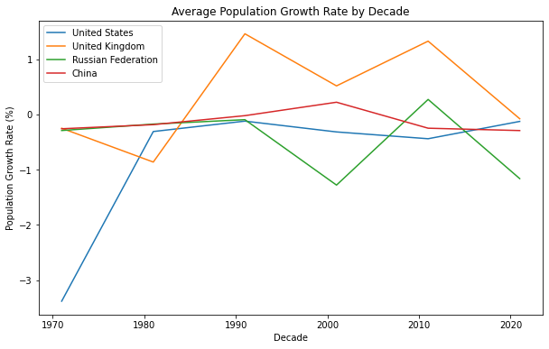

*Figure 1: Average Population Growth Rate from 1961-2021*

Figure 1 shows the average population growth rate for four countries (United States, United Kingdom, Russian Federation, and China) over several decades, from 1961 to 2021. The plot shows that all four countries experienced relatively high population growth rates in the 1960s and 1970s, with China having a relatively higher population growth rate. In the 1980s, the United Kingdom’s population growth rate went to the highest levels. Followed by a decline in 1990s, then a spike followed in 2000s till 2010 making a V- shaped line. In the recent decade, its population growth rate has declined to less than half percent annually.

From the 1960s till mid-1980s, Russia and China shared the same trajectory of annual population growth. From then, population growth rates of these countries show opposite trends where Russia’s population growth rate decreases while that of China’s increases. Russia made a V-Shape between 1990s and 2000s followed by a sharp decline in the recent decade as the UK did. As far as China is concerned, its growth rate has been on the decline since the 2000s.

The recorded data of the USA shows that its population growth rate was significantly low in 1960s and it started rising in 1970s and by the end of 1980 it was near to zero from greater than negative Three. It kept its trend intact till 1990 then followed a decline till 2010. In the recent decade, however, its population is growing in an upward trend. Overall, the plot shows that population growth rates have varied greatly between these four countries over the past several decades, with some experiencing rapid growth and others experiencing slower growth.

# Bar Plot: Top ten Countries with most population growth in 2021

The bar plot is a useful visualization technique for displaying numerical data, especially when comparing multiple categories. In this case, the bar plot is used to compare the population growth rates of different countries in 2021. The bar plot presents a clear visual representation of the top ten fastest growing countries, making it easy to compare and identify which countries have the highest population growth rates.

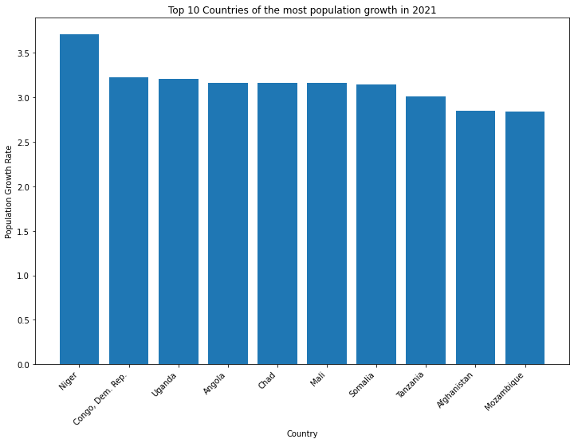

*Figure 2: Top ten Countries with most population growth in 2021*

Figure 2 visualization shows the top 10 countries with the highest population growth rates in 2021. The countries are listed on the x-axis and their population growth rates are displayed on the y-axis. The bars represent the population growth rates, with each bar representing a different country. The length of the bar indicates the magnitude of the population growth rate. From the visualization, it can be seen that most of the countries in the top 10 list are located in Africa, with the highest population growth rate being in Niger at over 4% per year. This is followed by Congo, Uganda, with almost the same growth rate followed by Angola, Chad and Mali. Somalia, and Tanzania have population growth rates around 3%. Afghanistan is the only country of Asia in the top ten population growing countries in 2021.

# Box Plot: Population Growth Rate (2021) Region Wise

The box plot is a useful visualization tool for displaying the distribution of a dataset. In this case, the box plot is used to show the distribution of the population growth rate across different regions in the year 2021.

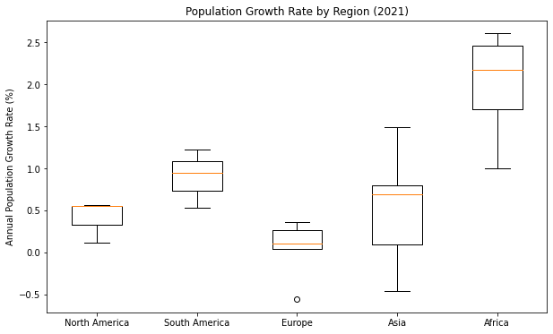

*Figure 3: Population Growth Rate (2021) Region Wise*

The box plot (Figure 3) effectively summarizes the distribution of population growth rates across different regions in the year 2021. The plot shows five boxes, one for each region - North America, South America, Europe, Asia, and Africa. The boxes display the median growth rate (indicated by the horizontal line in the box), the first quartile (bottom of the box), and the third quartile (top of the box). The whiskers extending from each box show the range of the data, excluding any outliers.

The box plot shows that the population growth rate is highest in Africa, followed by Asia and South America. North America and Europe have the lowest population growth rate. Additionally, the distribution of growth rates in Africa and Asia is more spread out than in the other regions, with a larger range of values. The box plot also shows that there are some outliers in the data for South America and Europe, indicating that there are a few countries in these regions with very high or very low population growth rates.

# Conclusion

In conclusion, this analysis gives light on the current situation of global population increase and its tendencies over the previous several decades. The graphs show the top 10 most populated countries in 2021, the population growth rate by decade for selected countries, the population growth rate by region in 2021, and the top 10 countries by population growth rate in 2021. The examination as a whole sheds light on the persistent problem of population growth and its effects on the world's ability to maintain its current standard of living. Through regular monitoring and study of these trends, policymakers and researchers can work towards establishing solutions to solve the issues provided by population expansion.